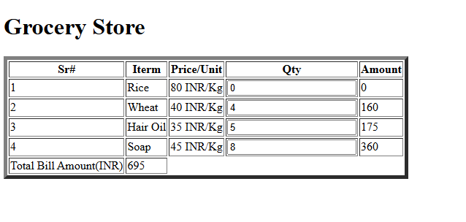
<!DOCTYPE html>
<html>
<head>
<script>
function call (){
var Qty=document.getElementById("Q1").value;
var amt= eval(Qty*80);
document.getElementById("div1").innerHTML=amt;
document.getElementById("Gross").innerHTML=eval(amt+ "+" +document.getElementById("Gross").innerHTML);
}
function cal2 (){
var Qty=document.getElementById("Q2").value;
var amt= eval(Qty*40);
document.getElementById("div2").innerHTML=amt;
document.getElementById("Gross").innerHTML=eval(amt+ "+" +document.getElementById("Gross").innerHTML);
}
function cal3 (){
var Qty=document.getElementById("Q3").value;
var amt= eval(Qty*35);
document.getElementById("div3").innerHTML=amt;
document.getElementById("Gross").innerHTML=eval(amt+ "+" +document.getElementById("Gross").innerHTML);
}
function cal4 (){
var Qty=document.getElementById("Q4").value;
var amt= eval(Qty*45);
document.getElementById("div4").innerHTML=amt;
document.getElementById("Gross").innerHTML=eval(amt+ "+" +document.getElementById("Gross").innerHTML);
}

</script>
<title>Francis Grocery Store</title></head>
<h1>
Grocery Store
</h1>
<table border="5">
<tr>
<th>Sr#</th>
<th>Iterm</th>
<th>Price/Unit</th>
<th>Qty</th>
<th>Amount</th>
</tr>
<tr>
<td>1</td>
<td>Rice</td>
<td>80 INR/Kg</td>
<td><input type="text" id="Q1" onchange="cal1();"></td>
<td><div id="div1">0</div></td>
</tr>
<tr>
<td>2</td>
<td>Wheat</td>
<td>40 INR/Kg</td>
<td><input type="text" id="Q2" onchange="cal2();"></td>
<td><div id="div2">0</div></td>
</tr>
<tr>
<td>3</td>
<td>Hair Oil</td>
<td>35 INR/Kg</td>
<td><input type="text" id="Q3" onchange="cal3();"></td>
<td><div id="div3">0</div></td>
</tr>
<tr>
<td>4</td>
<td>Soap</td>
<td>45 INR/Kg</td>
<td><input type="text" id="Q4" onchange="cal4();"></td>
<td><div id="div4">0</div></td>
</tr>
<tr>
<td>Total Bill Amount(INR)</td>
<td><div id="Gross">0</div></td>
</tr>
</table>
</html>

